Tracking, Kerning, and Leading?
Tracking
First up we have tracking, which refers to the space between each letter of a word, line, or block of text. It is also known as “letter-spacing.” Here’s an example, where the top has a tracking of 0, middle has 100, and the bottom has 250:
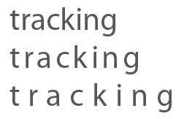
Kerning
Next we have kerning, which is the adjustment of space between two characters. Kerning is sometimes confused with tracking but whereas tracking deals with a whole word or sentence, kerning is adjusting the space between two letters to give a word a more visually pleasing result. Still confused? Let me give you an example:
Leading
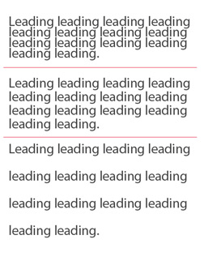
Last but not least we have leading, which is an easy one. Leading refers to the amount of space between the lines of text. It is also known as “line spacing” or “interline spacing.” Here’s an example with 3 different blocks of text:

