Name
Dates (Week of Jan 5-6 & Jan 9-13)
EXAMPLES OF DDDs
January 5, 2012
I believe Computer Graphics is a class where you learn how to enhance or change pictures. You can also design different types of things using programs on the computer. Computer Graphics and computer design might be very similar but I think there are some differences. Computer Graphics might be working more with pictures whereas design might be with different things like abstract art.
January 6, 2012
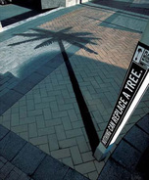
The advertisement says, “Nothing can replace a tree.” It has a pole in the place of where the tree use to be and the shadow is still of the tree. This is an advertisement for trying to save trees because so many are being cut down or destroyed. In my opinion this is effective because it is different from most pictures and catches your attention. I learned that you can alter pictures in different ways and make them look more interesting and out of the ordinary.
January 9, 2012
The advertisement has a chicken with a low carb silver chain around its neck. It says that they are keeping up with the trend; they are breaking out another selling point. The advertisement is for a new chicken product that has low carbs. I think this advertisement is somewhat effective because it does catch your attention. It might not be so clear what the message is because the letters at the top are a little small and the company logo is also small. We can learn that something that is funny and makes people look at it is an effective method for an advertisement.
January 10, 2012
In my opinion this is not a very good add for a bank. The bank logo at the bottom of the screen is very small and you can’t really tell the ad is for a bank. This ad looks more like a travel add to a beach or something. The information at the bottom is also very small and hard to see. The picture is also not very interesting and doesn’t really catch your eye.
January 11, 2012
I know the tools we learned on illustrator pretty well. My favorite so far is the paintbrush. I like the paintbrush because it has so many strokes and different styles and colors that are all fun to use. I also like the effects and patterns you can add to objects. There are so many possibilities that this program can offer.
January 12, 2012
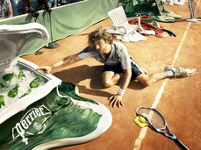
This is an advertisement of a man who is reaching for a drink as the whole world around him seems to be melting. He looks to be a tennis player. This advertisement is for Perrier water. I think this advertisement is good because it catches you attention and the product can be seen right away. The colors are bright and make you want to see what is happening as you look at it.
January 13, 2012- No DDD

